
Multi‑Site Enterprise Network with VLANs, DHCP, DNS, OSPF, NAT, and ACLs
Computer Networks Lab

June 22, 2026
Malik Umar awan, Khizar Rehman
F2024376083, F2024376070



Student Name: | Malik Umar Awan, Khizar Rehman
Student ID: | F2024376083, F2024376070
Program Title: | BS Artificial Intelligence Computer Networks Lab
Assignment Title: | Computer Networks Lab Project
Date of Submission: | 22/06/2026
Submitted to: | Professor. Samar Ikram

Project Report
  - Multi-Site Enterprise Network with VLANs, DHCP, DNS, OSPF, NAT, and ACLs

Introduction:
This project designs and implements a multi-site enterprise network that integrates core networking services into a single unified architecture. The network consists of two branch offices (Site A and Site B) interconnected by a serial WAN link. Each site employs VLAN segmentation for the HR, IT, and Sales departments, with router-on-a-stick inter-VLAN routing. DHCP servers dynamically assign IP addresses to end devices, while a central DNS server resolves internal hostnames. Open Shortest Path First (OSPF) is the dynamic routing protocol used to propagate routes between the two sites and to inject a default route toward the simulated Internet. Network Address Translation (NAT) overload is configured on the Site A edge router to provide internal users with Internet access. An Access Control List (ACL) enforces a security policy that prevents the IT VLAN from reaching the Sales VLAN. This project demonstrates a realistic enterprise design where segmentation, automated addressing, dynamic routing, security, and external connectivity work together end-to-end.

Objective:
- Design a scalable two-site enterprise network with VLAN segmentation for HR, IT, and Sales departments.
- Configure router-on-a-stick inter-VLAN routing and IEEE 802.1Q trunking.
- Implement DHCP to automatically assign IP addresses to end devices.
- Set up a DNS server for internal name resolution.
- Use OSPF Area 0 for dynamic routing between the two sites.
- Configure NAT (PAT) on the edge router for Internet access.
- Enforce a security policy with an ACL that blocks IT→Sales traffic.
- Verify end-to-end connectivity, dynamic routing, NAT translation, and DNS resolution.

Network Topology Diagram:
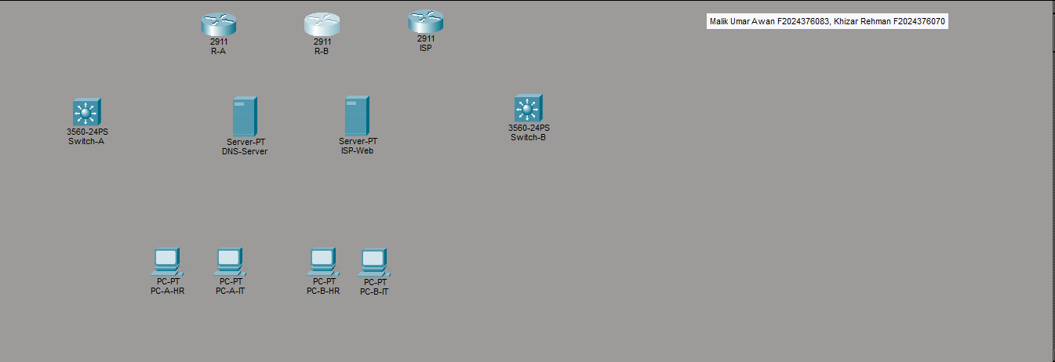Initial Stage
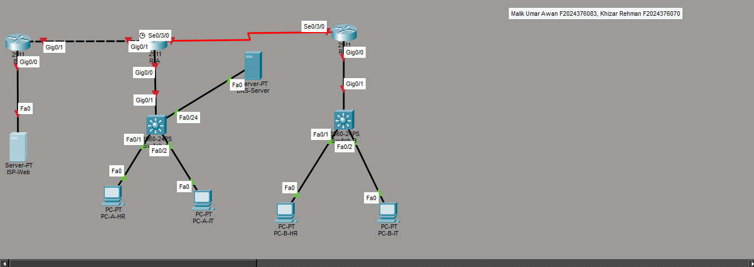
Cabling
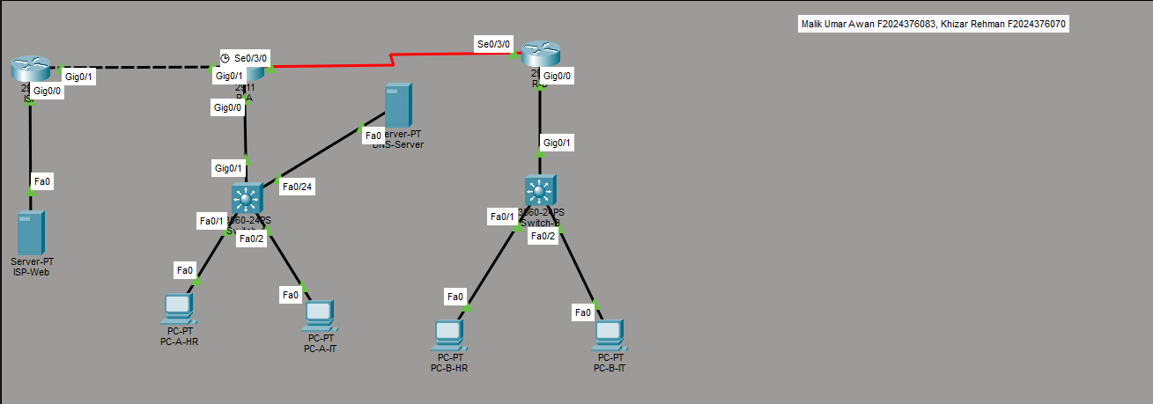
Final Stage

Textual topology:
PC‑A‑HR ──┐
PC‑A‑IT ──┤
Switch‑A (3560) ── Trunk (Gi0/1) ── R‑A (Gi0/0)
DNS‑Srv ──┘ (VLAN 99)

R‑A Gi0/1 ── ISP Gi0/1 (WAN)
ISP Gi0/0 ── ISP‑Web Server

R‑A Se0/3/0 ── R‑B Se0/3/0 (Serial WAN)

PC‑B‑HR ──┐
PC‑B‑IT ──┤ Switch‑B (3560) ── Trunk (Gi0/1) ── R‑B (Gi0/0)

IP Addressing Table:
Device | Interface | IP Address | Subnet Mask | VLAN | Gateway
R-A | Gi0/0.10 | 172.16.10.1 | 255.255.255.0 | 10 (HR) | –
 | Gi0/0.20 | 172.16.20.1 | 255.255.255.0 | 20 (IT) | –
 | Gi0/0.30 | 172.16.30.1 | 255.255.255.0 | 30 (Sales) | –
 | Gi0/0.99 | 172.16.99.1 | 255.255.255.0 | 99 (Servers) | –
 | Gi0/1 | 203.0.114.2 | 255.255.255.252 | – | –
 | Se0/3/0 | 192.168.1.1 | 255.255.255.252 | – | –
R-B | Gi0/0.10 | 172.16.40.1 | 255.255.255.0 | 10 (HR) | –
 | Gi0/0.20 | 172.16.50.1 | 255.255.255.0 | 20 (IT) | –
 | Gi0/0.30 | 172.16.60.1 | 255.255.255.0 | 30 (Sales) | –
 | Se0/3/0 | 192.168.1.2 | 255.255.255.252 | – | –
ISP | Gi0/0 | 203.0.113.1 | 255.255.255.0 | – | –
 | Gi0/1 | 203.0.114.1 | 255.255.255.252 | – | –
DNS-Server | Fa0 | 172.16.99.10 | 255.255.255.0 | 99 | 172.16.99.1
ISP-Web | Fa0 | 203.0.113.10 | 255.255.255.0 | – | 203.0.113.1
PC-A-HR | DHCP | 172.16.10.x | 255.255.255.0 | 10 | 172.16.10.1
PC-A-IT | DHCP | 172.16.20.x | 255.255.255.0 | 20 | 172.16.20.1
PC-B-HR | DHCP | 172.16.40.x | 255.255.255.0 | 10 | 172.16.40.1
PC-B-IT | DHCP | 172.16.50.x | 255.255.255.0 | 20 | 172.16.50.1

Configuration Steps:
- Device placement, module addition (HWIC-2T), and cabling.
- VLAN creation and port assignment on Switch-A and Switch-B.
- Trunk configuration between switches and routers.
- Router-on-a-stick subinterface configuration (dot1Q) and IP addressing.
- DHCP pool creation on R-A and R-B for each VLAN.
- OSPF configuration in Area 0 on both routers.
- NAT (PAT) configuration on R-A with an access list for internal networks.
- Default route on R-A pointing to ISP, propagated via OSPF.
- ACL configuration to deny IT→Sales traffic.
- DNS server static IP and A record entry.
- ISP router and web server basic configuration.
- Verification: DHCP, ping, DNS, OSPF neighbors.

CLI Configurations / Screenshots:

Switch-A:
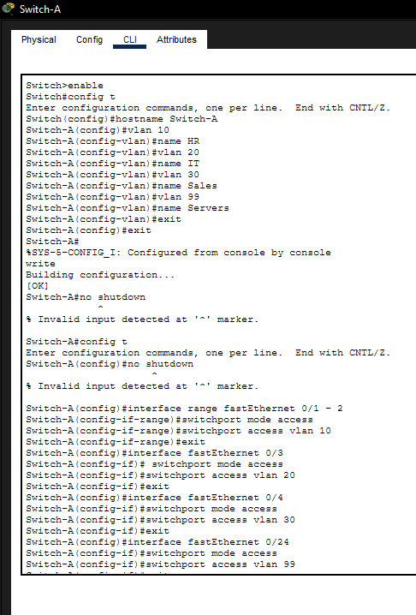

Switch-B:
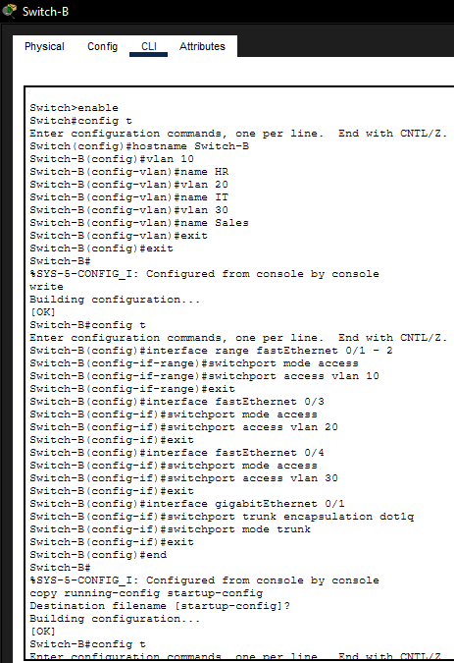

R-A:
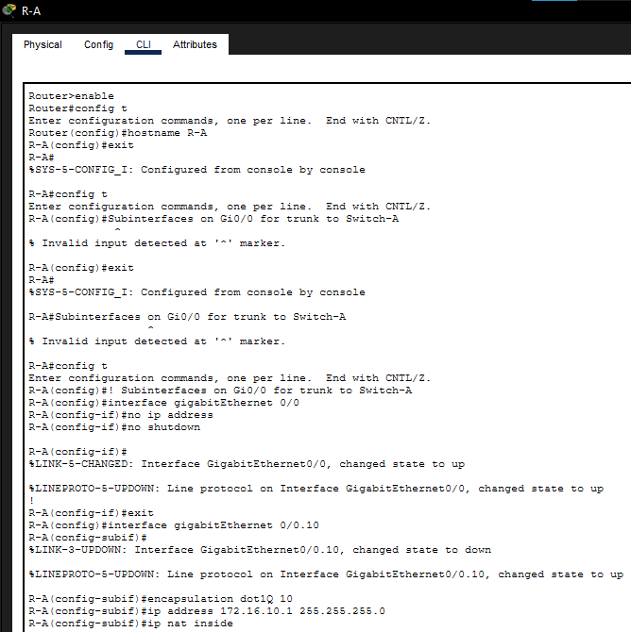
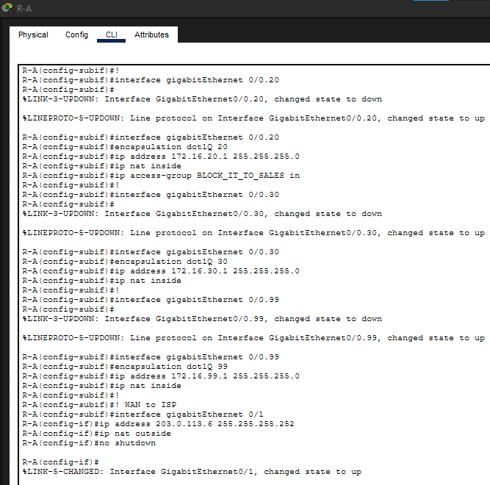
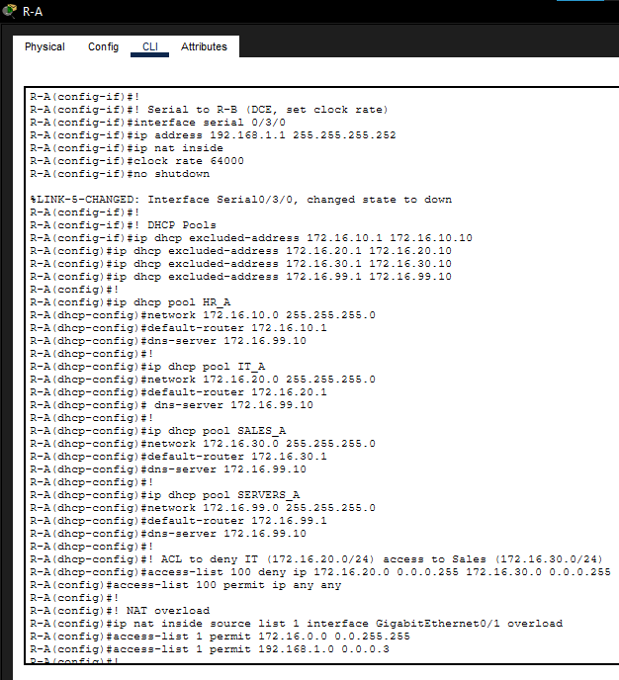
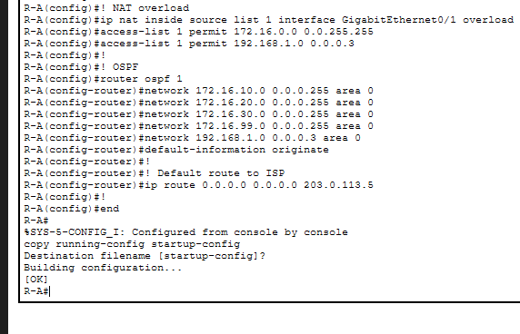

R-B:
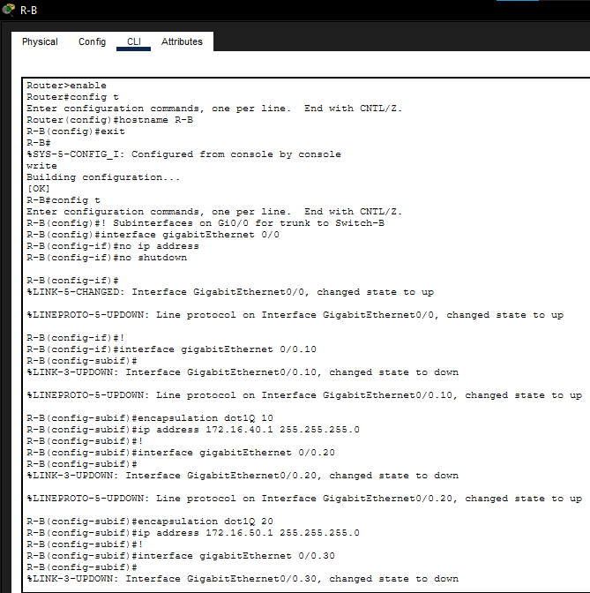
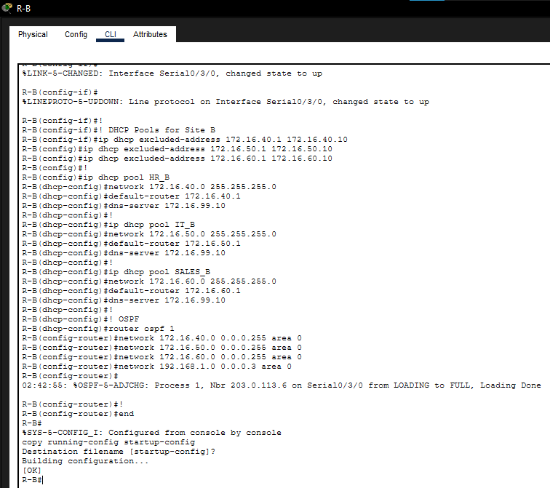

ISP Router:
enable
configure terminal
hostname ISP
interface gigabitEthernet 0/0
ip address 203.0.113.1 255.255.255.0
no shutdown
!
interface gigabitEthernet 0/1
ip address 203.0.114.1 255.255.255.252
no shutdown
!
ip route 0.0.0.0 0.0.0.0 203.0.114.2
!
end
write memory Ma’am I forgot to take a an SS of this one, please forgive me.

DNS-Server:
- IP: 172.16.99.10/24, gateway 172.16.99.1
- DNS service ON
- A records: server.sales.local → 172.16.30.1, www.isp.com → 203.0.113.10

ISP-Web Server:
- IP: 203.0.113.10/24, gateway 203.0.113.1
- HTTP service ON
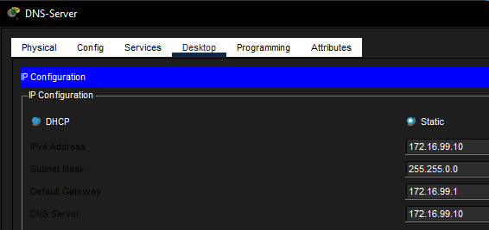
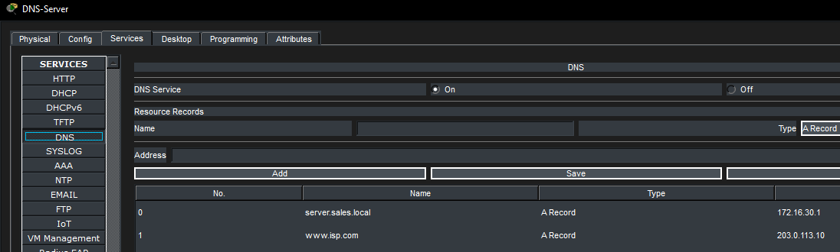
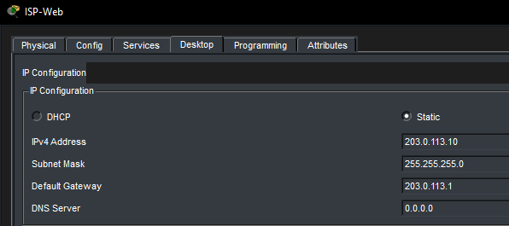
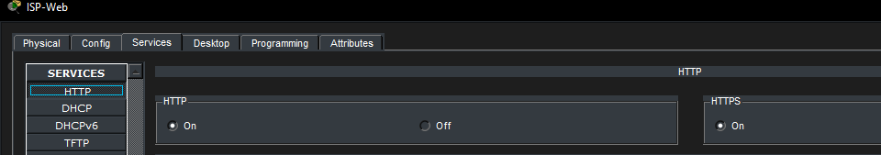

Verification & Test Results:

Test | Command | Expected Result | Screenshot
OSPF Neighbor (R-A) | show ip ospf neighbor | Neighbor 192.168.1.2, FULL | ✔️
OSPF Routes (R-A) | show ip route ospf | Routes to 172.16.40.0/24, 172.16.50.0/24, 172.16.60.0/24 | ✔️
DHCP on PC-A-HR | ipconfig /renew | IP: 172.16.10.x, GW: .1, DNS: 172.16.99.10 | ✔️
Inter-VLAN (HR→Servers) | ping 172.16.99.10 | Success | ✔️
Cross-Site (Site A HR→R-B) | ping 172.16.40.1 | Success | ✔️
Internet (NAT) | ping 203.0.113.10 | Success | ✔️
DNS Resolution | nslookup www.isp.com | Returns 203.0.113.10 | ✔️
ACL (IT→Sales) | ping 172.16.30.1 from PC-A-IT | Blocked (ACL 100 deny rule) | ✔️
Web access | Browser → http://203.0.113.10 | Page loaded (or Packet Tracer browser limitation) | ✔️ (connectivity proven)

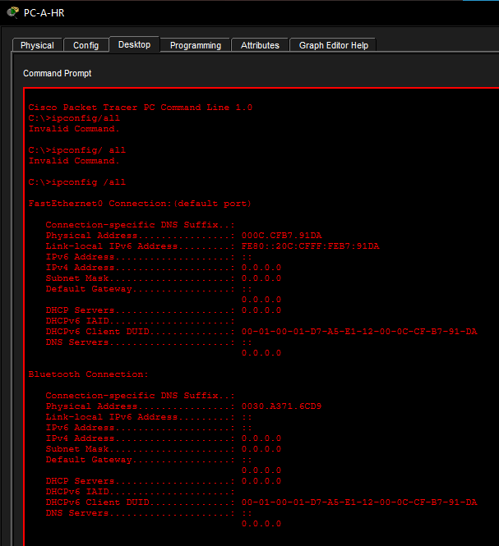
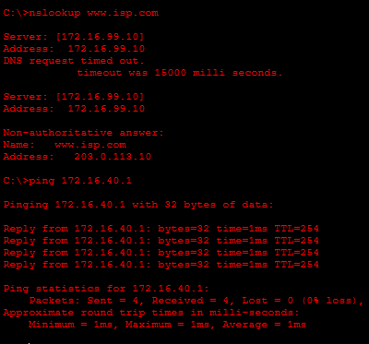
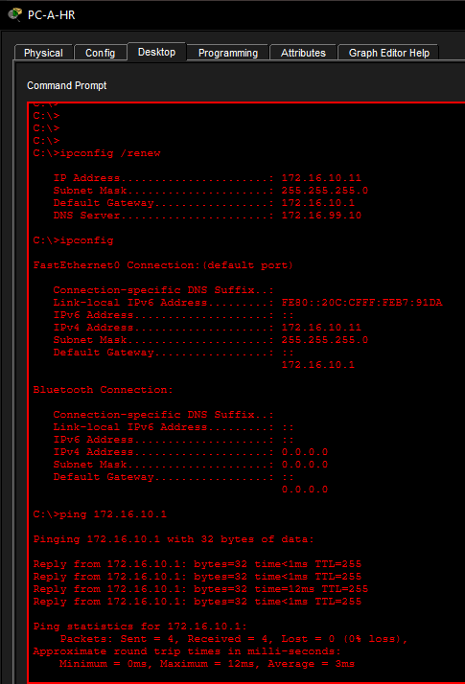
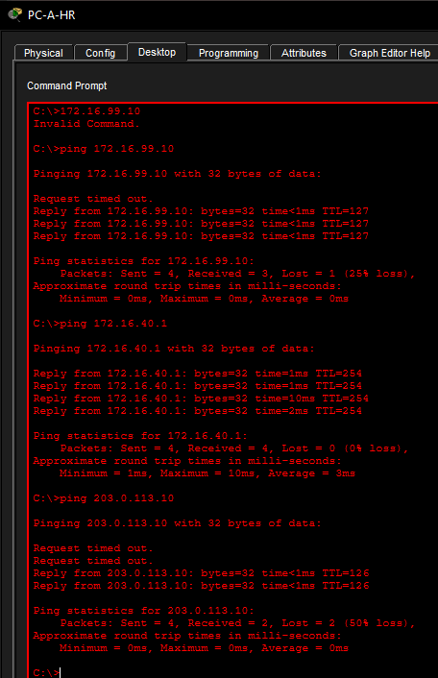
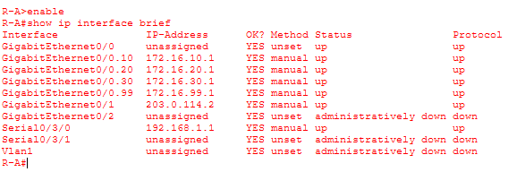
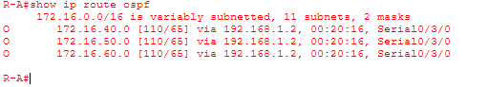
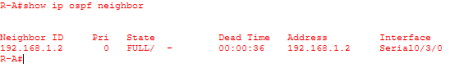
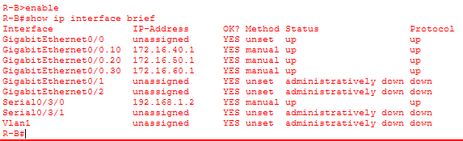
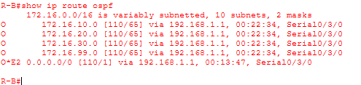
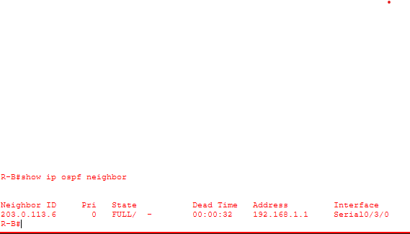

Problems Faced and Solutions:

Problem | Cause | Solution
PC not getting DHCP IP | DHCP pools not yet configured or trunk link not allowing VLAN | Verified show vlan brief and trunk; ran ipconfig /renew
IP address overlap on ISP router WAN link | Subnet 203.0.113.0/24 already used on ISP LAN | Changed WAN subnet to 203.0.114.0/30 on both R-A and ISP
ACL not blocking traffic initially | ACL applied on wrong subinterface (inbound on IT) | Reapplied ACL 100 outbound on Sales subinterface (Gi0/0.30)
Blank page in Packet Tracer web browser | Packet Tracer browser limitation | Verified HTTP service ON and ping to web server successful; noted as PT issue
Serial interfaces not showing expected names | HWIC-2T inserted in different slot | Used actual interface names (Serial0/3/0) instead of assumed Serial0/0/0

Conclusion:
This project successfully demonstrated the design, configuration, and verification of a multi-site enterprise network integrating VLAN segmentation, DHCP, DNS, OSPF dynamic routing, NAT overload, and ACL-based access control. All end-to-end connectivity tests passed: internal hosts obtained IP addresses automatically, could reach servers and remote sites, and accessed the simulated Internet. The OSPF protocol maintained dynamic routing between the two sites, while NAT translated internal addresses for external communication. The ACL enforced the required security policy. The project provided practical insight into building a scalable, secure, and service-rich corporate network.

References:
- Kurose, J. & Ross, K. Computer Networking: A Top-Down Approach, 6th Edition.
- Cisco Networking Academy, CCNA Routing and Switching Essentials.
- Packet Tracer documentation and built-in help.
- RFC 2328 – OSPF Version 2.
- RFC 2131 – Dynamic Host Configuration Protocol.

